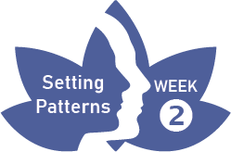
Three Step Meditation – Instructions

This meditation can be conducted sitting down, standing or lying down. Its purpose is to provide awareness and balance in times of automatic reaction to events.

Step 1 – Audit:
- Adopt a dignified posture, whether sitting or standing and ‘tune in’ to the present moment.
- Close your eyes and bring your awareness inside asking yourself:
What thoughts am I having? What feelings am I experiencing? What is my body doing?
Remember – this is my experience right now; the world won’t alter to suit me!
Step 2 – Breath and body awareness:
- Concentrate on your breathing, starting with the nose and mouth, then the chest and then the abdomen.
- Now focus on the parts of your body in contact with the floor and/or chair, feel the weight and contact.
- Now focus on where your skin meets your clothing, feel the touch of your clothes on your skin.
- Now focus on the space just outside the body, where you inhabit space.
- Now reverse the process, from space, to skin, to surface, to breathing and finally to mind.
Step 3 – Sustain the awareness:
- Now take this feeling from inside and bring it consciously into the rest of your day.

