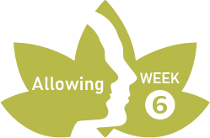
PRACTICE RECORD FORM
WEEK 6
Record on this form each time you practice. Make notes for discussion at the next session.

Day/date | Practice  (Yes/No) | Comments
Day/Date: | Guided meditation:  Breathe:
Day/Date: | Guided meditation:  Breathe:
Day/Date: | Guided meditation:  Breathe:
Day/Date: | Guided meditation:  Breathe:
Day/Date: | Guided meditation:  Breathe:
Day/Date: | Guided meditation:  Breathe:

