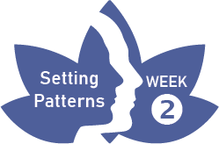
Pleasant Experience Calendar
Be aware of the experience as it happens
Focus your attention by use of these questions:
DAY | EXPERIENCE | HOW DID YOUR BODY FEEL? | WHAT THOUGHTS AND FEELINGS?
 | e.g Noticing a bird singing | Suddenly relaxed and light | Pleasure, what a lovely sound.
1
2
3
4
5
6

